2015 REGISTRATION FORM
4 PLAYER GOLF SCRAMBLE
JUNIOR CURLING FUNDRAISER
THE RIDGE AT MANITOU
(Dinner at Parry Sound Curling Club)

SAT., MAY 9, 2015 ***NEW | SHOTGUN START 10:00 PM
ENTRY DEADLINE APRIL 28TH | PLEASE ARRIVE 1/2 HOUR EARLY
ENTRY FEE: $420. PER TEAM | INCLUDES GOLF, CART, DINNER
PRIZES

Please send this form to:
jerry.marcia@hotmail.com
or - Jerry Reevie, 20 Skerryvore Circle , McDougall ON P2A 2W9
Make cheque per 4 player team so team is entered, payable to Parry Sound Junior Curling.
Include contact name and phone number as well as team player names.
For more info call Jerry or Marcia at 705-746-7216.
Name:
(Player #1)
Phone:
Address:
City/Prov: |  | PC
Player 2:
Player 3:
Player 4: | 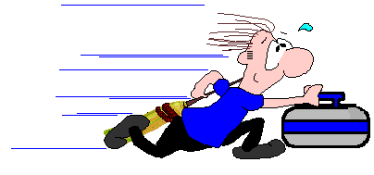
Note: Make cheque payable to Parry Sound Junior Curling

