MIXED DOUBLES CURLING RULES

.

RULES:

A Mixed Doubles team consists of two players (one male and one female). Each team throws 5 stones each.
- Player 1 delivers the first and last stone.
- Player 2 delivers stones 2, 3 and 4.
- The player delivering the first stone can change from end to end. (The delivery rotation is determined by the team at the start of each end.)
- There are no designated sweepers – so brushing is done by the thrower and the person holding the broom.
- 2 stones are positioned before each end begins. (see notes about placement)
- The team whose stationary stone is placed in the position in front of the house (position A) shall deliver first in that end, and the team whose stationary stone is placed in the house (position B) shall deliver the second stone of that end.
- Each game is 8 ends. Scoring is the same as in regular curling. In the case of a tie – then an extra end will be played to determine the winner.
- No stone, including those in the house, can be removed from play prior to the delivery of the fourth stone of an end. If there is a violation, the delivered stone shall be removed from play, and any displaced stone(s) shall be replaced to their original position by the non-offending team.

Note regarding the first 4 stones thrown:

Both stationary stones (the one in the house and the one in front of the house) are included in this ruling. It is the 4th delivered stone of each end that is allowed to remove any stone from play.

Example: Team A’s 1st stone cannot be a takeout on any stone, team B’s 1st stone cannot be a takeout on any stone, Team A’s 2nd stone cannot be a takeout on any stone, Team B’s 2nd stone can now be a takeout and remove any stone from play. (Basically a 3 rock rule.)

- 2 –

Note regarding placement of the 2 stationary stones:

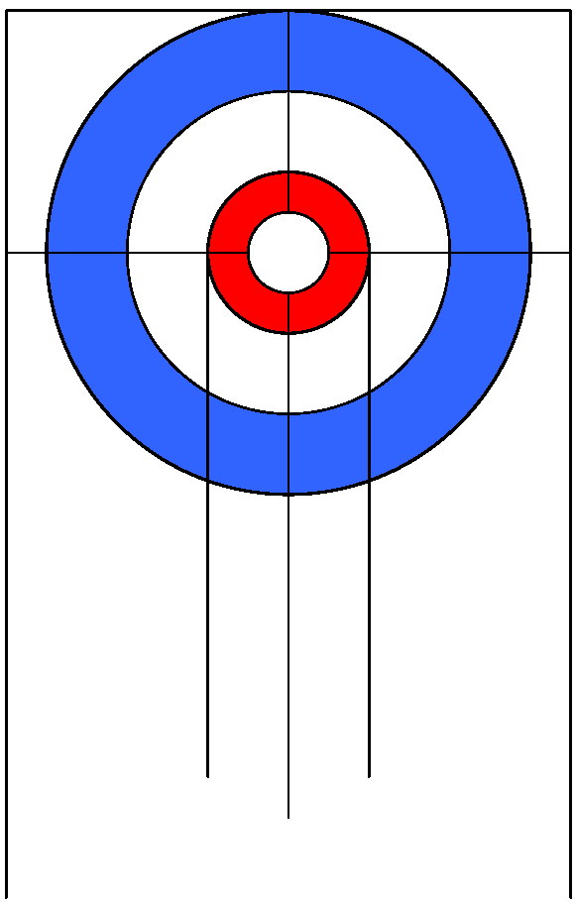
Prior to the start of every end, one team shall instruct the game umpire to place their team’s stationary stone (1), and their opponent’s stationary stone (1), in either position A or B:
A - A stone bisecting the centre line, midway between the hog line and the front of the house;
OR
B - A stone on the back half of the button, bisecting the centre line and touching the tee line.

Note: Depending on ice conditions the placement of the “A” stone in front of the house can vary. (If very ‘straight’ ice - can be closer to the hog line, if very ‘swingy’ - can be closer to the house.) This position can’t be altered during a game.

The maximum distance that this stone can be adjusted from the position 3 feet– measured from the edge of the stone if placed in the normal position, to the closest edge of the stone placed in the new position,

Who determines the placement of the stationary stones:

It is determined by a coin toss in the first end.

Remaining ends - the team that lost the end has the decision on the placement.

If a blank end - the team that did not deliver the last stone in that end shall have the decision on placement in the next end.

Sweeping Clarification:

One player delivers the stone and the other player must be positioned inside the hog line, and on the ice surface of the playing end, while the team is in the process of delivery

